**BUDGET ANALYSIS**

**INSTITUTION- UNIVERSITY OF NORTH TEXAS**

**GROUP- POWER RANGERS**

ANU REDDY CHUKKALURI- 11715021

ASHWIN JAYAKUMAR- 11634102

EMMIDI BADRINATH YESHWARITHA-11648431

LAKSHMI SRAVANI KURADA- 11707953

VAMSI PRIYANKA BADITHI- 11708580

1. In the initial phase of the data life cycle, the primary step undertaken is **DATA GENERATION**. For our project, we've acquired information concerning budget recommendations across various positions and anticipated salaries within different departments.
2. Following data generation, next phase is the **DATA COLLECTION**. We collected the data based on our requirement dealing specifically with the total budget amount among the various government departments and average budgeted pay rate by grade the departmental description.
3. The subsequent phase involves **DATA PROCESSING**.

**Hadoop** is the primary tool for processing the data. We monitored the Hadoop cluster and entered command **‘ps -ef | grep -i hadoop’** to know the process status.

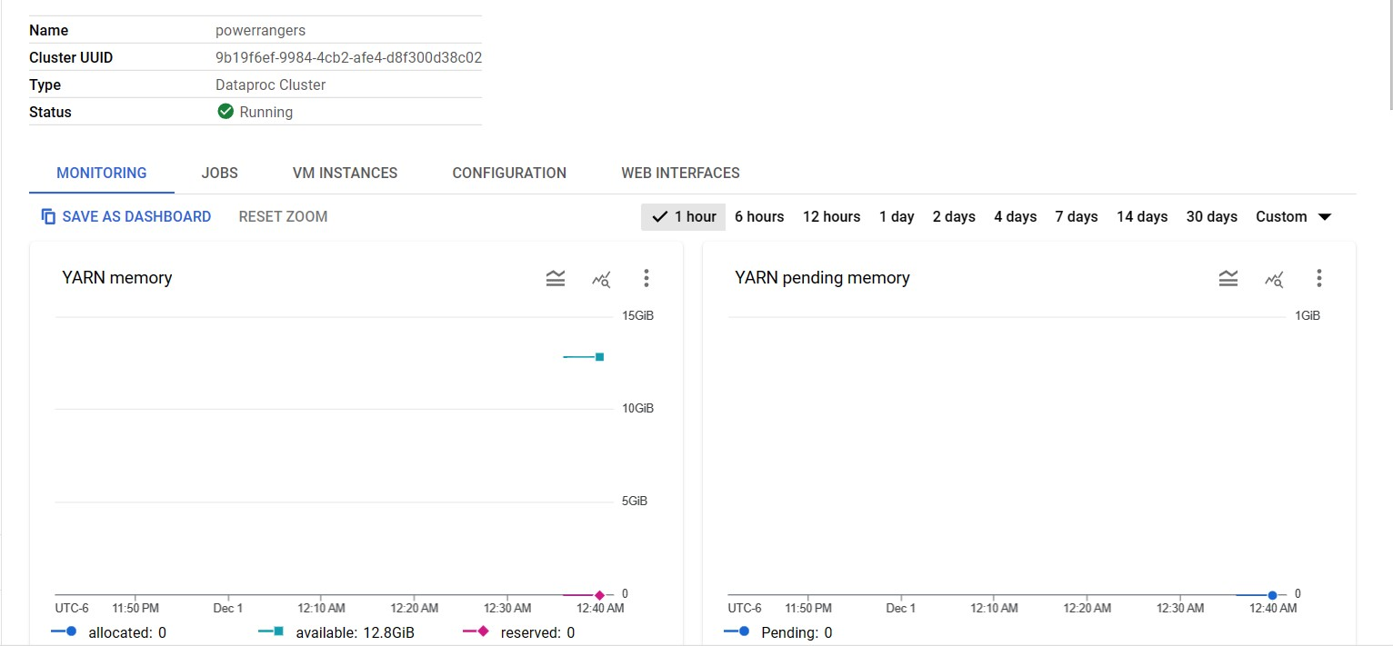

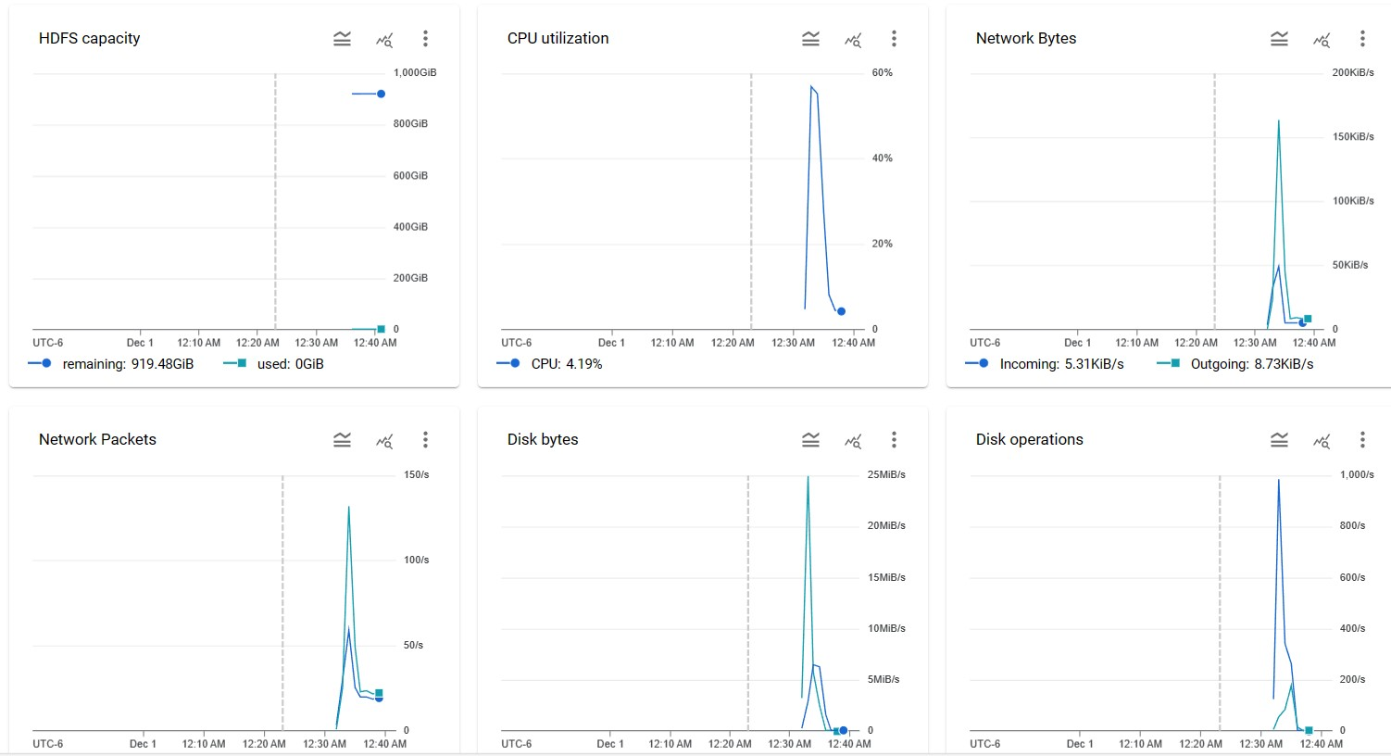 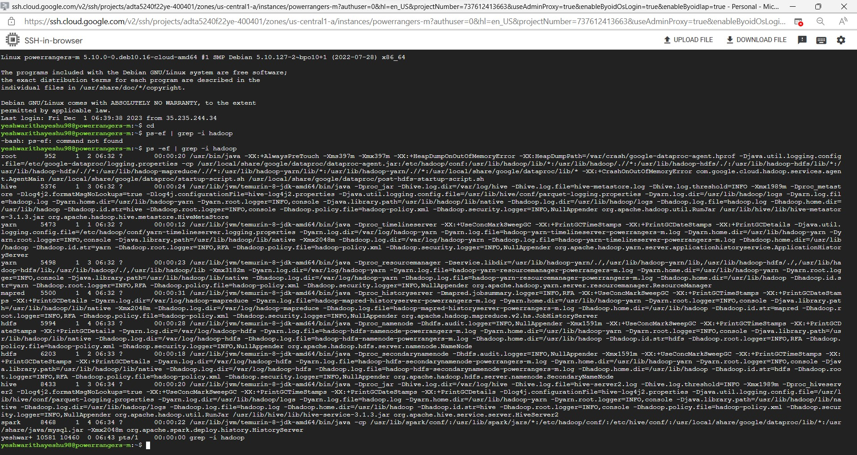 **OpenRefine** serves as our tool of choice for cleansing the dataset.

**STEPS IN OPEN REFINE-**

Upon uploading the CSV file onto OpenRefine, we have adhered to fundamental data processing principles, encompassing several key steps:

* Substituting null values within the 'SUBSECTION' column with the string "No Subsection". Eliminating any duplicate entries that might be present within the dataset.
* Leveraging OpenRefine's unique clustering functionality to eradicate lemmatized text across columns.

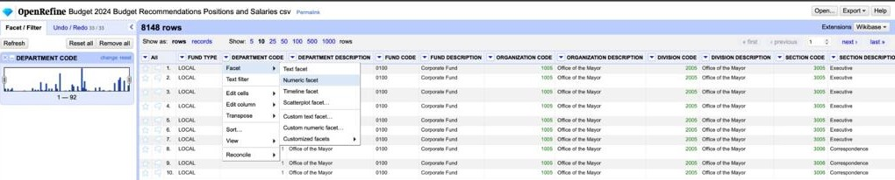

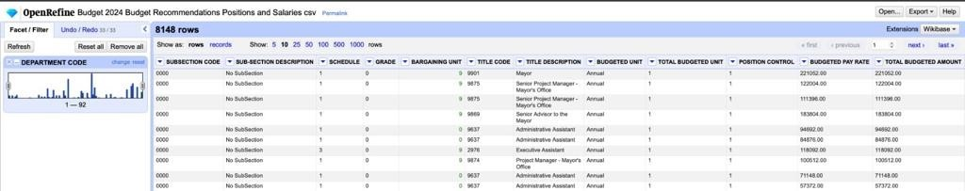

1. The subsequent stage in the data life cycle involves **STORAGE**. To house the cleansed dataset, we have opted for Google Cloud Platform's (GCP) storage—specifically, leveraging GCP's storage buckets.

* Uploaded the csv file into the GCP bucket accordingly.

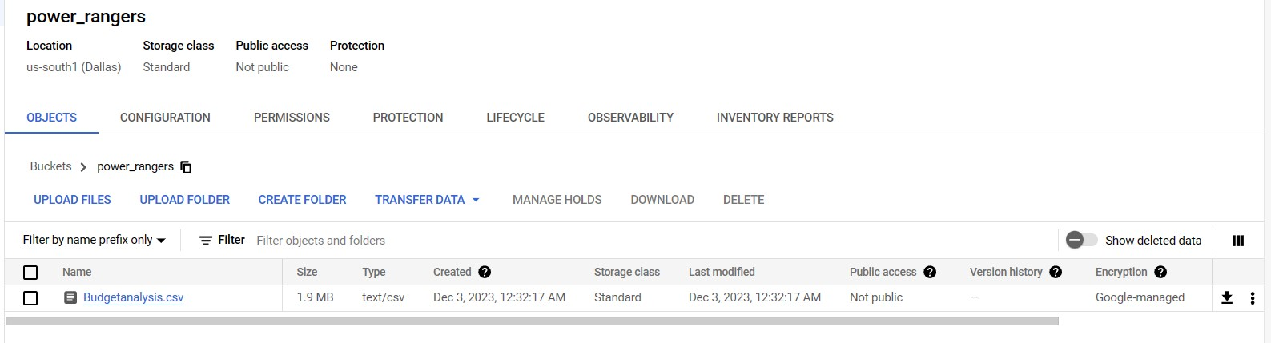

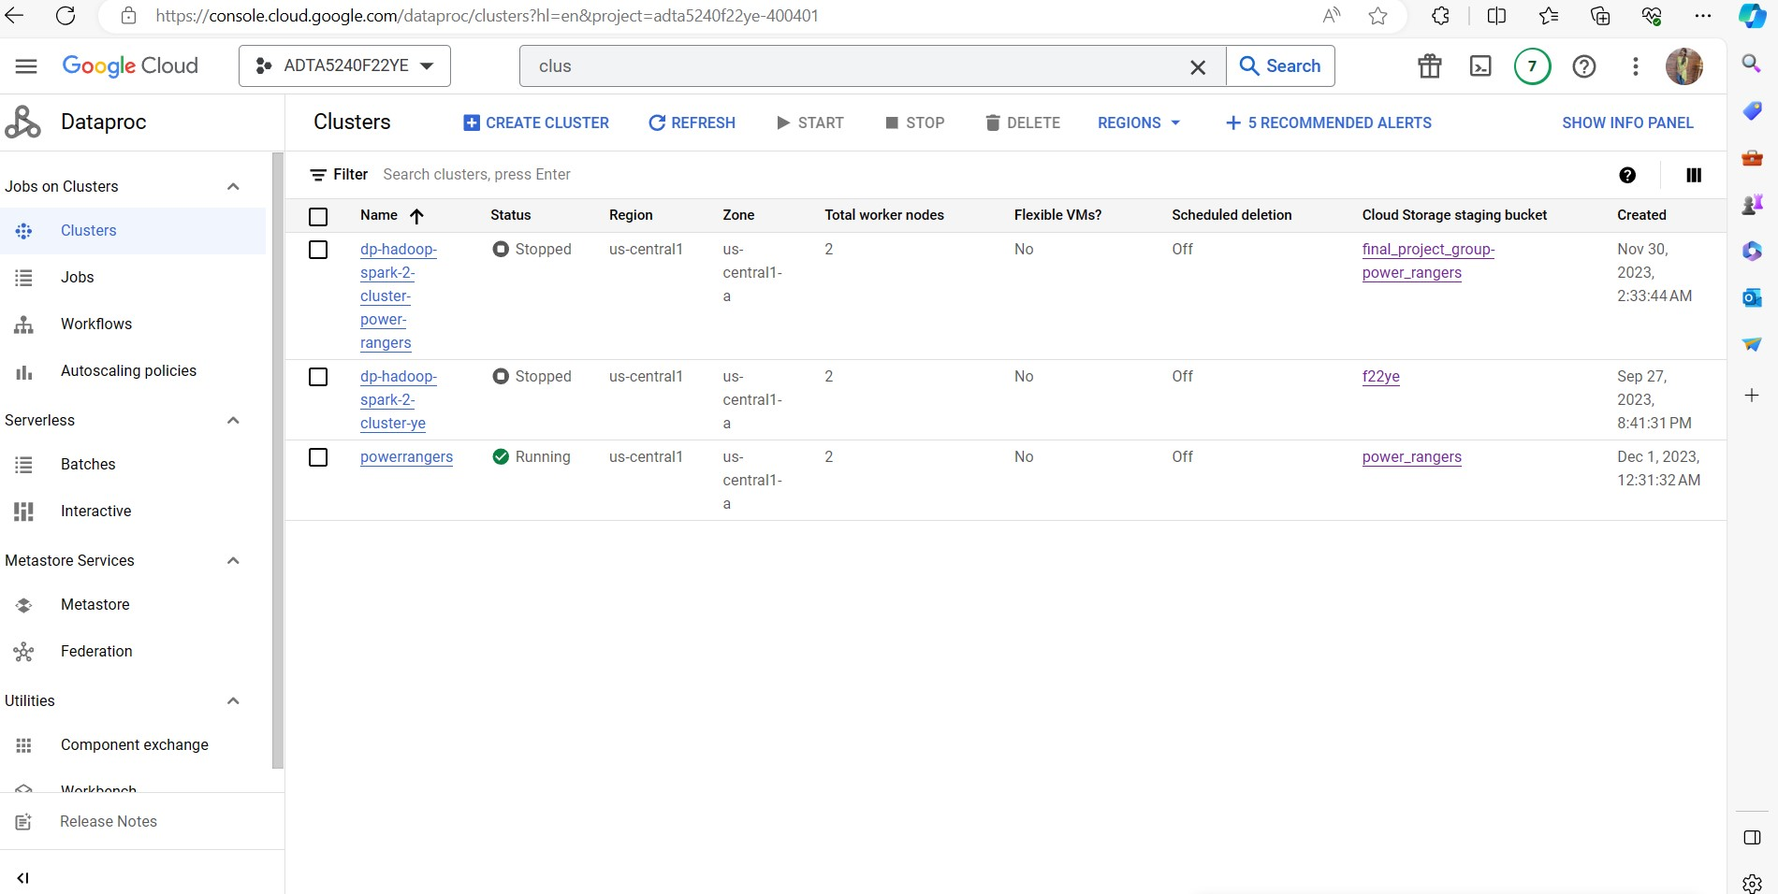

1. Next step is one of the main phases of Data lifecycle- **DATA MANAGEMENT AND ANALYSIS**.

**Apache Hive** and **Spark SQL** are used here to carry out the management phase of data life cycle.

* We created a new directory in HDFS, to move the files from storage bucket to Manager Node and then into HDFS directory. Then, we copied the contents of the bucket (GCP) to the Manager Node and then moved them to HDFS ecosystem.
* We enter spark by entering ‘spark-sql’ and run the commands with limit 1 and 5 from the table ‘powerrangers_123’.

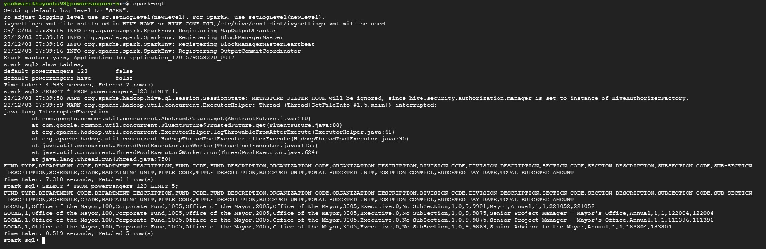

**Big Query** is used analyzing the data and gaining the visual representation of the budget analysis. Firstly, we loaded the csv file into BigQuery. Then, we created an external table to compare the required columns namely-Department description, total budgeted amount, average pay rate and grade. Then we carried out basic SQL commands to run the queries and gain the necessary output.

* CREATING AN EXTERNAL TABLE- **‘externaltable1NEWEXTERNALTABLE’**

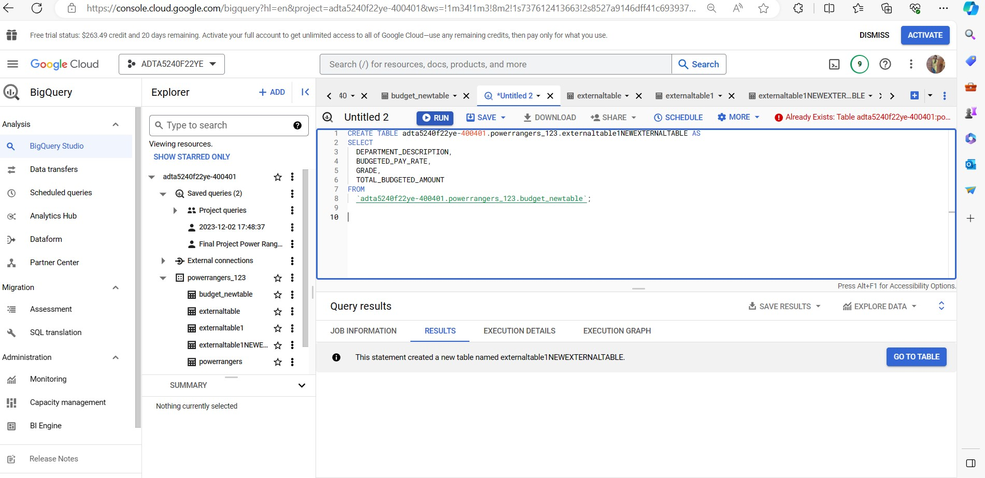

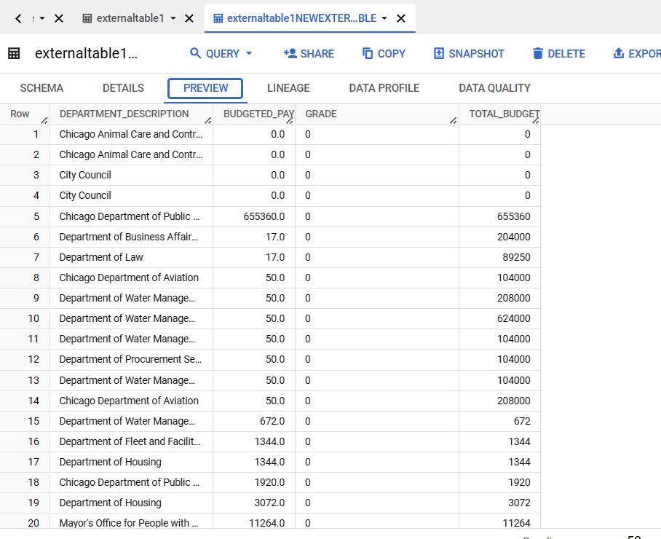

* **EXECUTING THE BASIC SQL COMMANDS IN BIG QUERY**

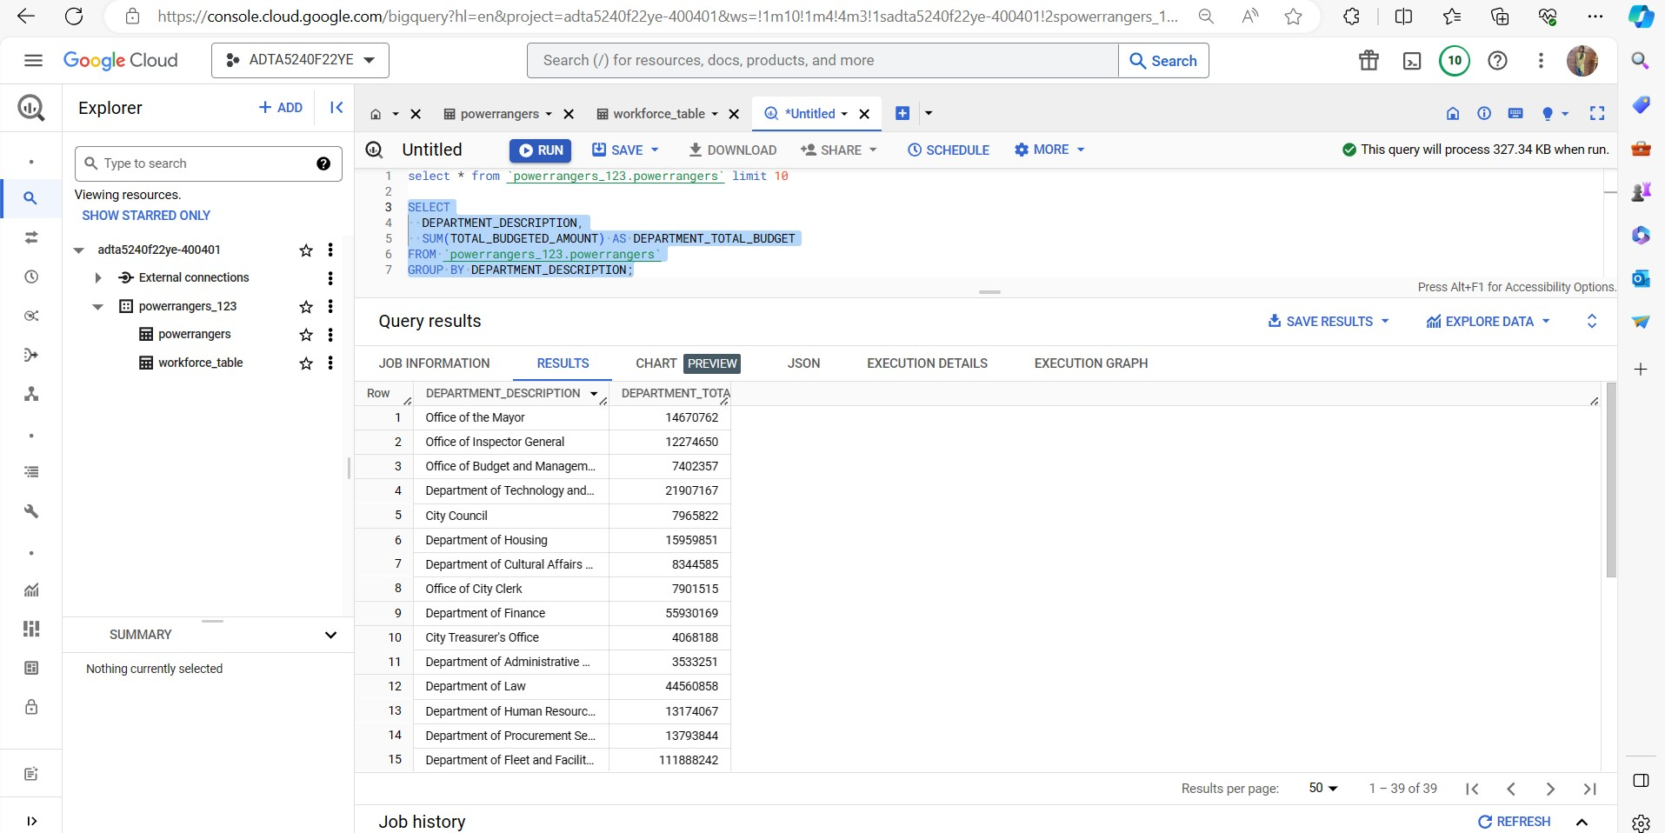

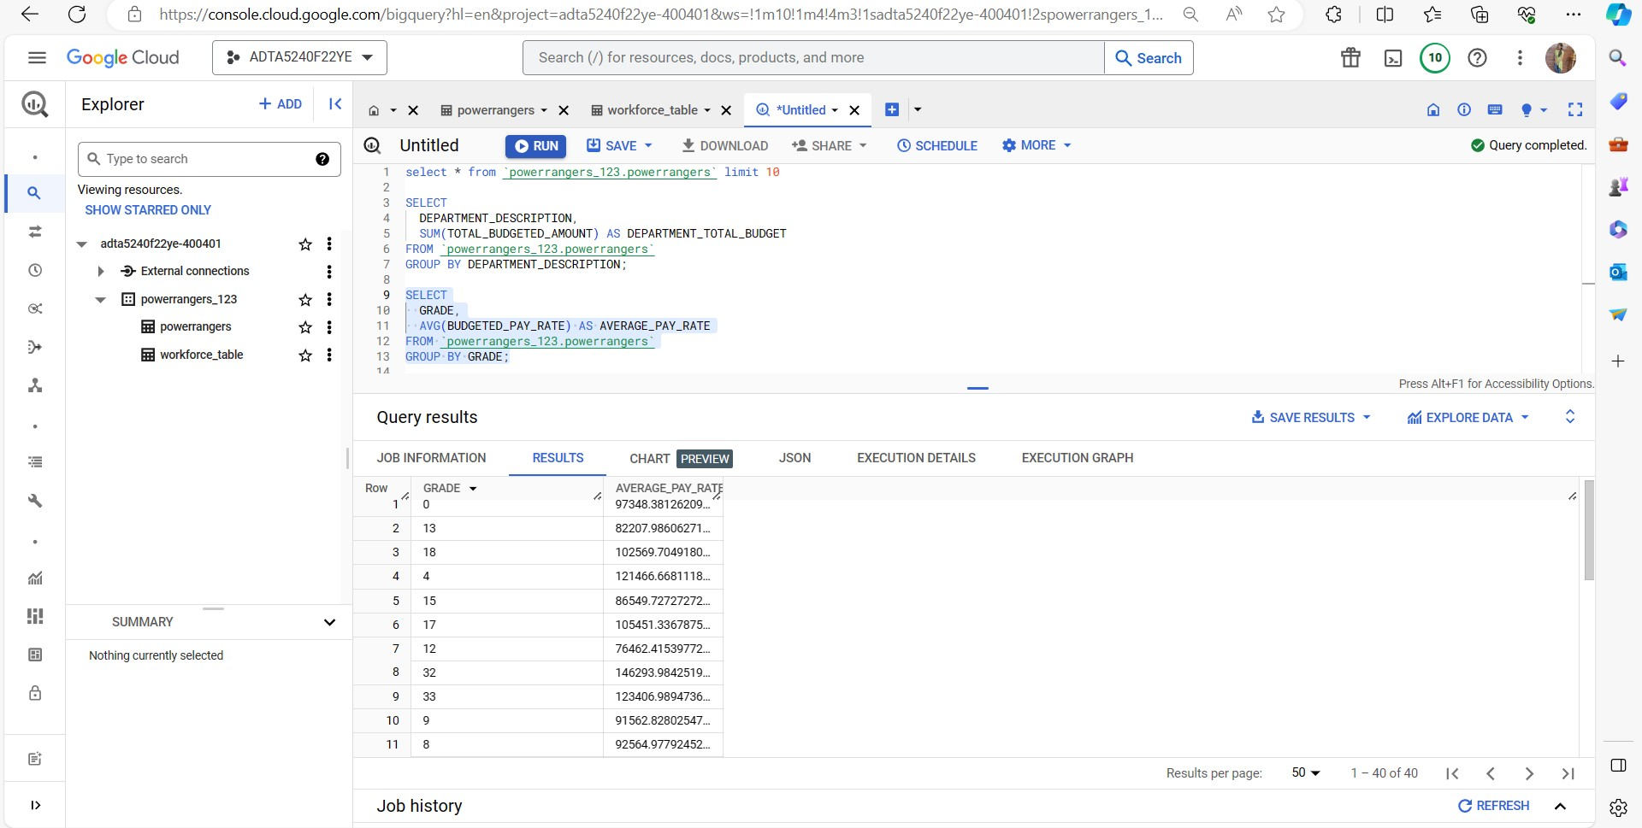

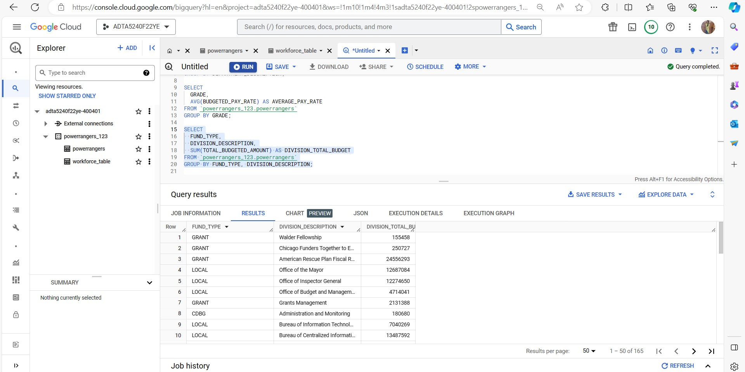 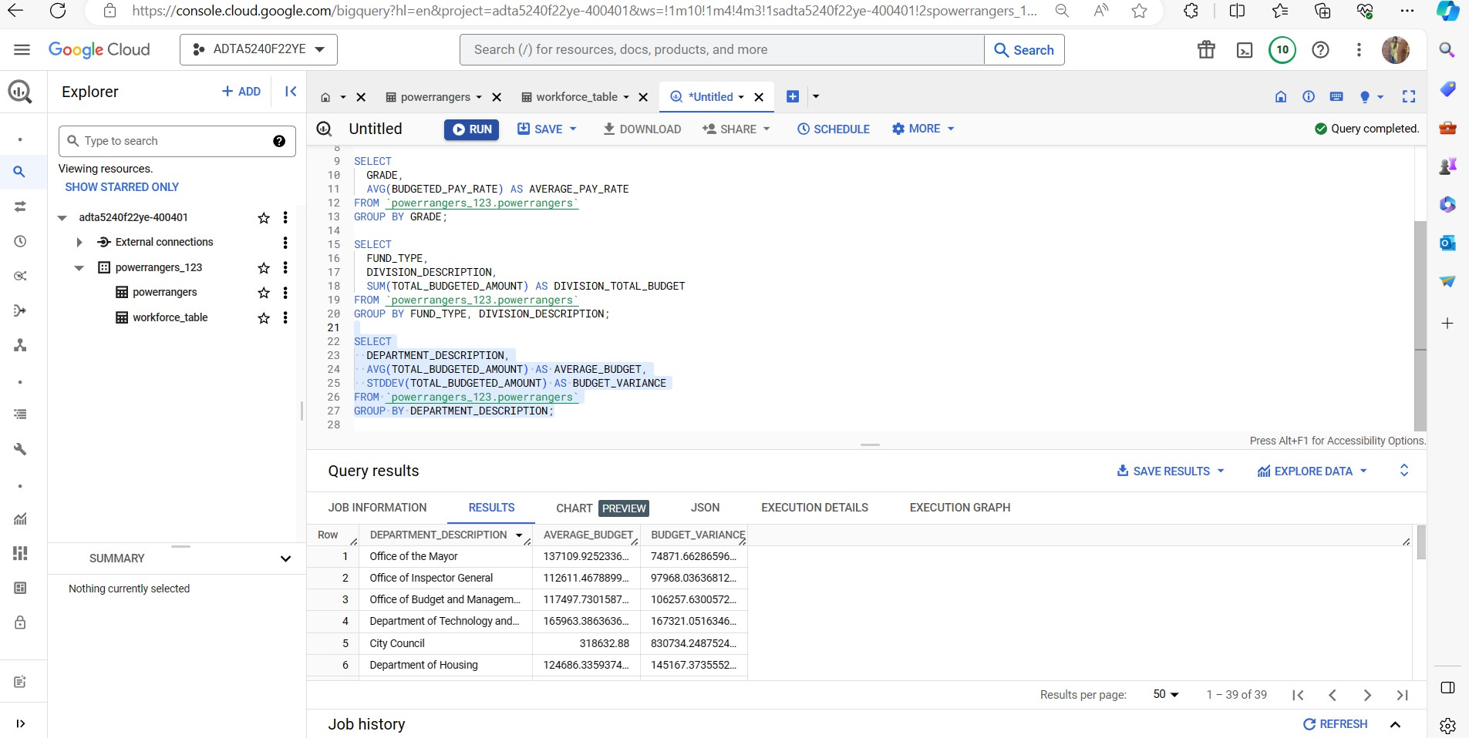 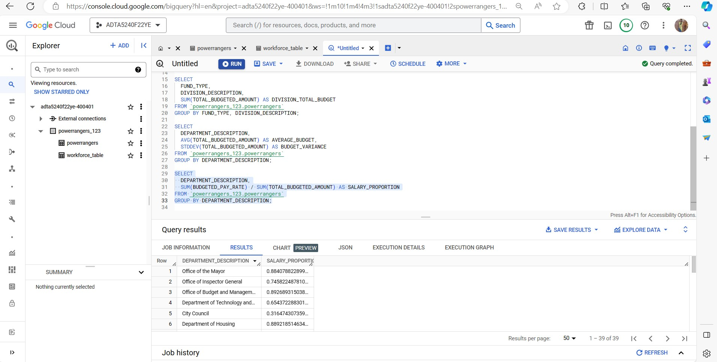 6. Next is the **DATA VISUALIZATION** phase. We used **Big Query** and **Tableau** for carrying out the visualization steps.

Graph1 and Graph 2 encase the level of budget distribution according to the departments and grades.

**BIG QUERY VISUALIZATION GRAPHS-**

**GRAPH 1-**

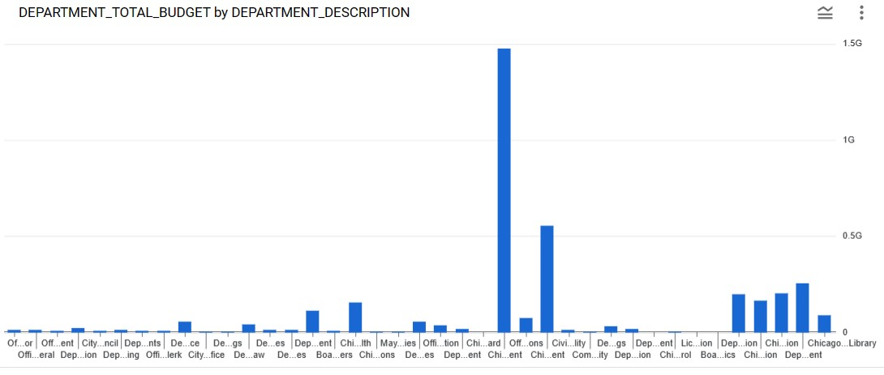

**GRAPH 2-**

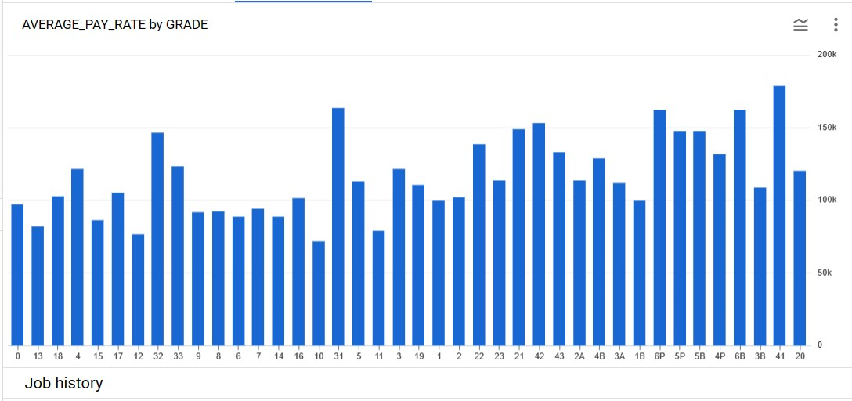

**TABLEAU VISUALIZATION GRAPHS-**

**GRAPH 1-**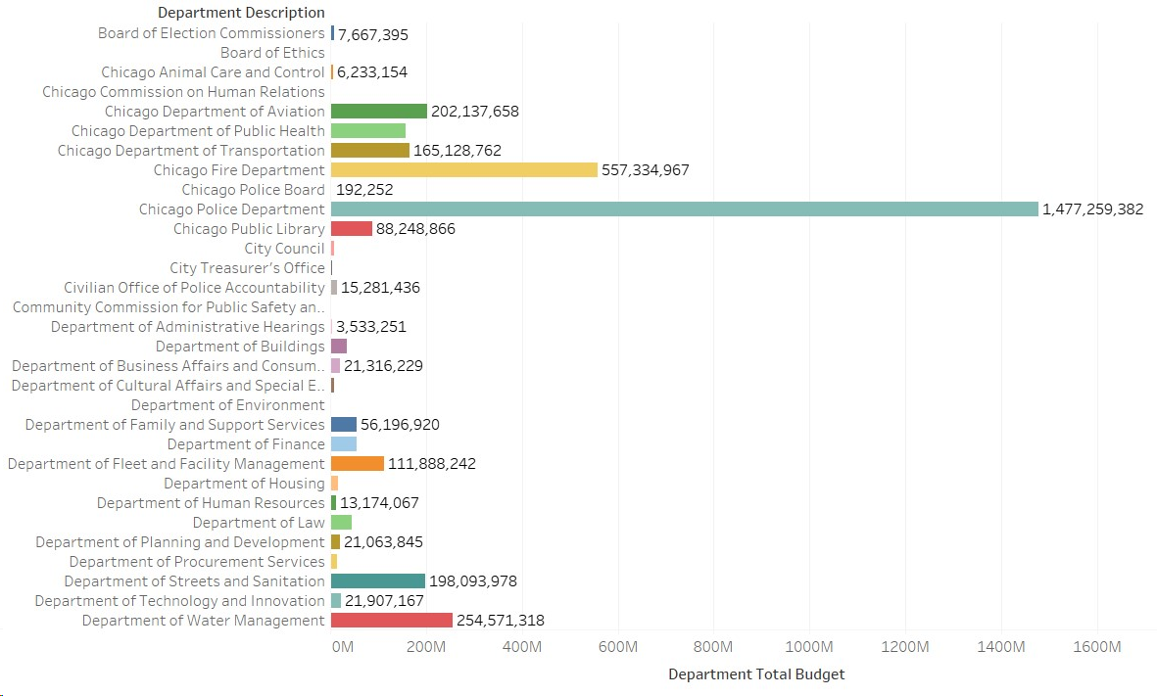

**GRAPH 2-**

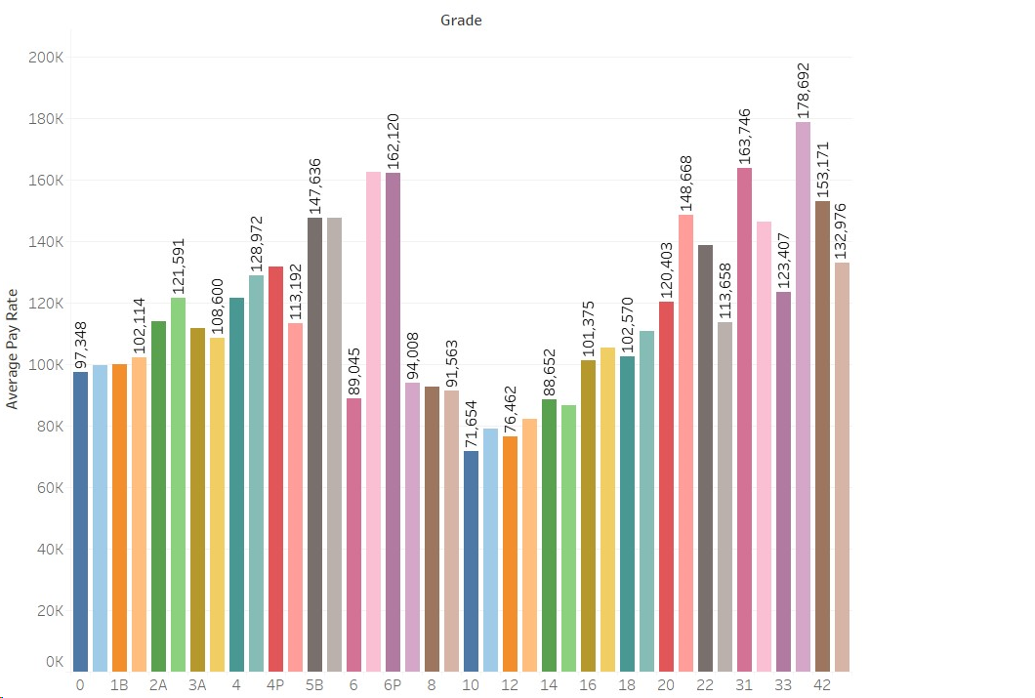

1. The final step is **DATA INTERPRETATION**. Here we interpreted the data based on the graphs obtained from the previous step.

* The first graphical representation between total budget amount and department description depicts the budgeted amount among the various departments. We observed a disparity in the Chicago Police Department’s budget as it dominates all the other departments.
* The second graphical representation between the average pay rate and grade displays a balanced distribution of average pay across various grades.

**REFERENCES**

* *8 steps in the data life Cycle | HBS Online*. (2021, February 2). Business Insights Blog. <https://online.hbs.edu/blog/post/data-life-cycle>
* *The Data Life Cycle - the Data Science Institute at Columbia University*. (2020, September 20). The Data Science Institute at Columbia University. <https://datascience.columbia.edu/news/2018/the-data-life-cycle/>
* *What is Hadoop and What is it Used For?  |  Google Cloud*. (n.d.). Google Cloud. <https://cloud.google.com/learn/what-is-hadoop>